Triangle Proportionality Theorem

Definition
# Source: AI Source: Provided by: [Data Path: Persons Table -> ID Column: 1, Name_En Column: Motasem Essam] -> From: [ChatGPT] on [7/25/2026]
The Triangle Proportionality Theorem, also called the Basic Proportionality Theorem (BPT), states that if a line is drawn parallel to one side of a triangle and intersects the other two sides, then it divides those two sides proportionally.
For triangle $ABC$, if $D$ lies on $AB$, $E$ lies on $AC$, and:
$$DE∥BC$$
then:
$$\boxed{\frac{AD}{DB}=\frac{AE}{EC}}$$
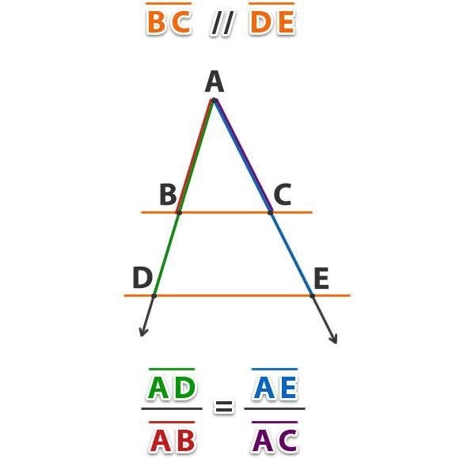
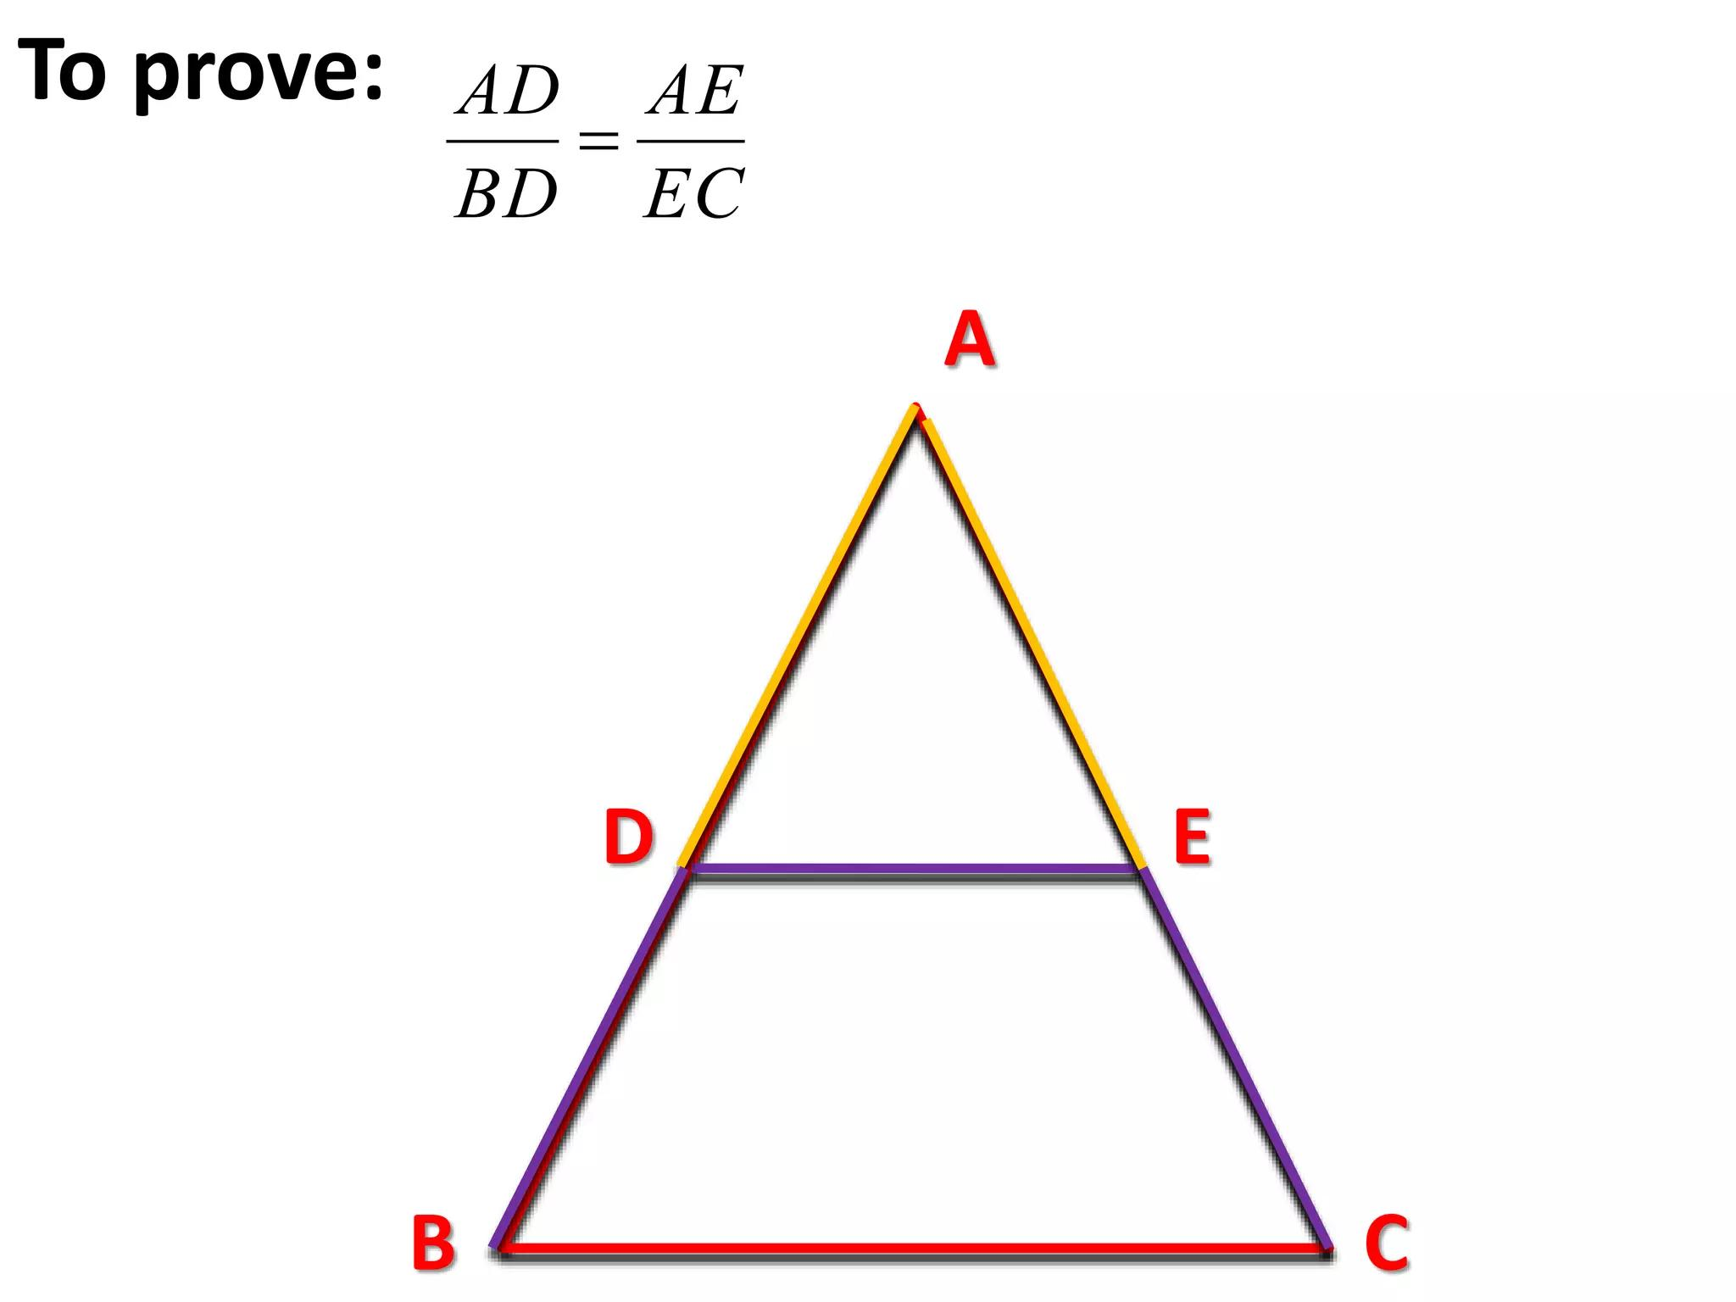
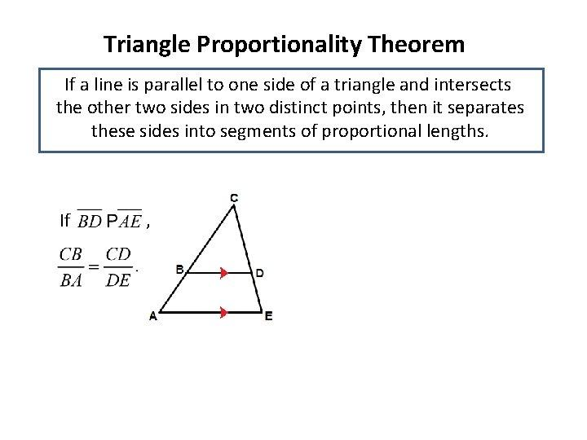

Purpose
# Source: AI Source: Provided by: [Data Path: Persons Table -> ID Column: 1, Name_En Column: Motasem Essam] -> From: [ChatGPT] on [7/25/2026]
The Triangle Proportionality Theorem is used to:
- Find unknown side lengths.
- Establish proportional relationships between line segments.
- Solve geometric problems involving parallel lines.
- Determine whether a line is parallel to a side of a triangle.
- Support proofs involving similar triangles.
- Apply proportional reasoning in geometry.

Basic Configuration
# Source: AI Source: Provided by: [Data Path: Persons Table -> ID Column: 1, Name_En Column: Motasem Essam] -> From: [ChatGPT] on [7/25/2026]
Consider triangle $ABC$.
A segment $DE$ is drawn so that:
$$D∈AB \\ E∈AC$$
and:
$$DE∥BC$$
The smaller triangle $ADE$ and the original triangle $ABC$ are similar:
$$\boxed{△ADE∼△ABC}$$
Therefore, their corresponding sides are proportional.
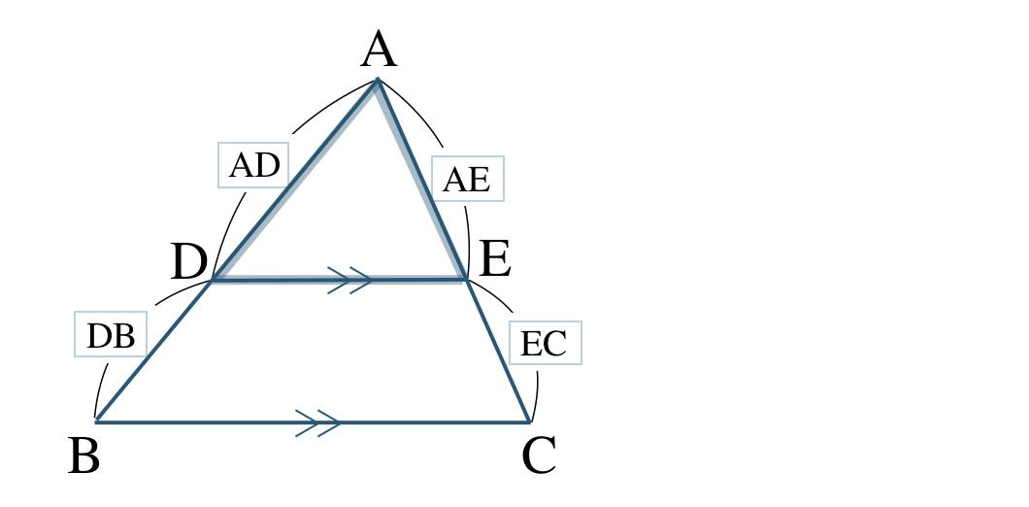
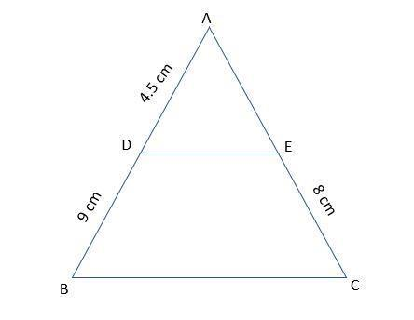
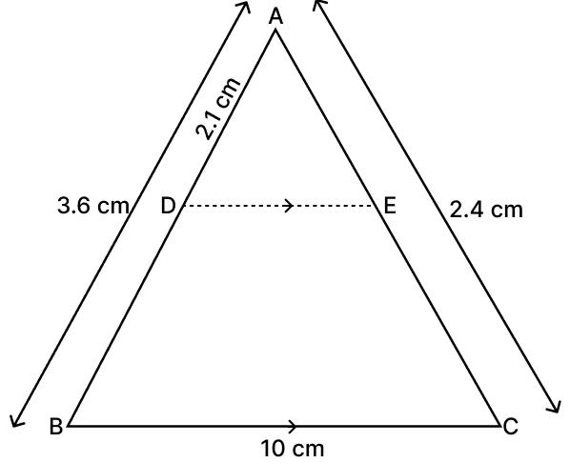

Mathematical Representation
# Source: AI Source: Provided by: [Data Path: Persons Table -> ID Column: 1, Name_En Column: Motasem Essam] -> From: [ChatGPT] on [7/25/2026]
If:
$$DE∥BC$$
then:
$$\boxed{\frac{AD}{AB}=\frac{AE}{AC}=\frac{DE}{BC}}$$
The theorem also gives:
$$\boxed{\frac{AD}{DB}=\frac{AE}{EC}}$$
Both forms express the proportional relationship created by the parallel segment.

Example 1 — Finding an Unknown Segment
# Source: AI Source: Provided by: [Data Path: Persons Table -> ID Column: 1, Name_En Column: Motasem Essam] -> From: [ChatGPT] on [7/25/2026]
Suppose:
$$AD=4 \\ DB=6 \\ AE=8$$
and $DE∥BC$.
Using the theorem:
$$\frac{AD}{DB}=\frac{AE}{EC}$$
Substitute:
$$\frac{4}{6}=\frac{8}{EC}$$
Cross-multiply:
$$4\left(EC\right)=6\left(8\right) \\ 4EC=48$$
Therefore:
$$\boxed{EC=12}$$
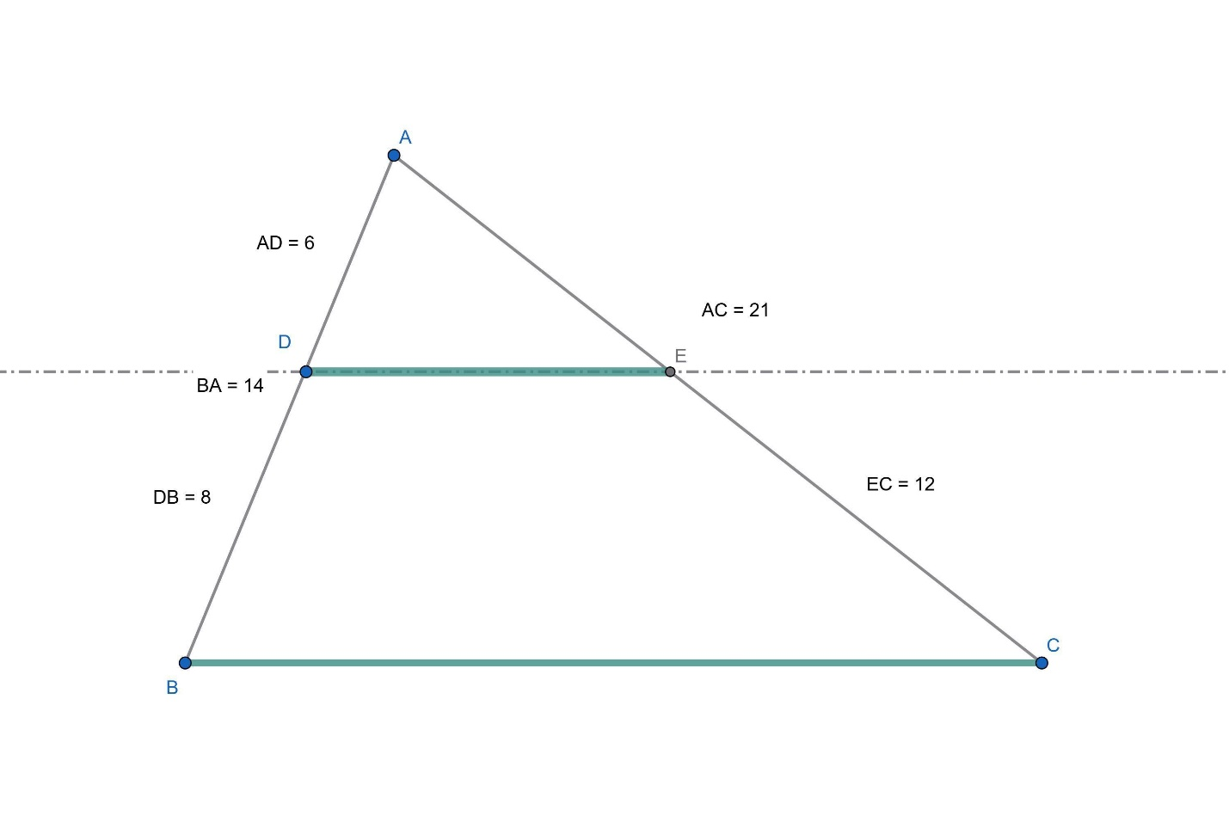

Example 2 — Using Corresponding Side Ratios
# Source: AI Source: Provided by: [Data Path: Persons Table -> ID Column: 1, Name_En Column: Motasem Essam] -> From: [ChatGPT] on [7/25/2026]
Suppose:
$$AD=5, AB=15$$
and:
$$AC=18$$
Since $DE∥BC$:
$$\frac{AD}{AB}=\frac{AE}{AC}$$
Therefore:
$$\frac{5}{15}=\frac{AE}{18}$$
Simplify:
$$\frac{1}{3}=\frac{AE}{18}$$
Thus:
$$AE=6 \\ \boxed{AE=6}$$

Example 3 — Finding a Missing Side
# Source: AI Source: Provided by: [Data Path: Persons Table -> ID Column: 1, Name_En Column: Motasem Essam] -> From: [ChatGPT] on [7/25/2026]
Suppose:
$$AD=6, DB=9$$
and:
$$AE=8$$
Find $EC$.
Using:
$$\frac{AD}{DB}=\frac{AE}{EC}$$
we get:
$$\frac{6}{9}=\frac{8}{EC}$$
Cross-multiply:
$$6EC=72$$
Therefore:
$$\boxed{EC=12}$$

Relationship with Similar Triangles
# Source: AI Source: Provided by: [Data Path: Persons Table -> ID Column: 1, Name_En Column: Motasem Essam] -> From: [ChatGPT] on [7/25/2026]
The Triangle Proportionality Theorem is closely related to triangle similarity.
If:
$$DE∥BC$$
then corresponding angles are equal:
$$∠ADE=∠ABC \\ ∠AED=∠ACB$$
and:
$$∠A=∠A$$
Therefore:
$$\boxed{△ADE∼△ABC}$$
From similarity, corresponding sides are proportional.
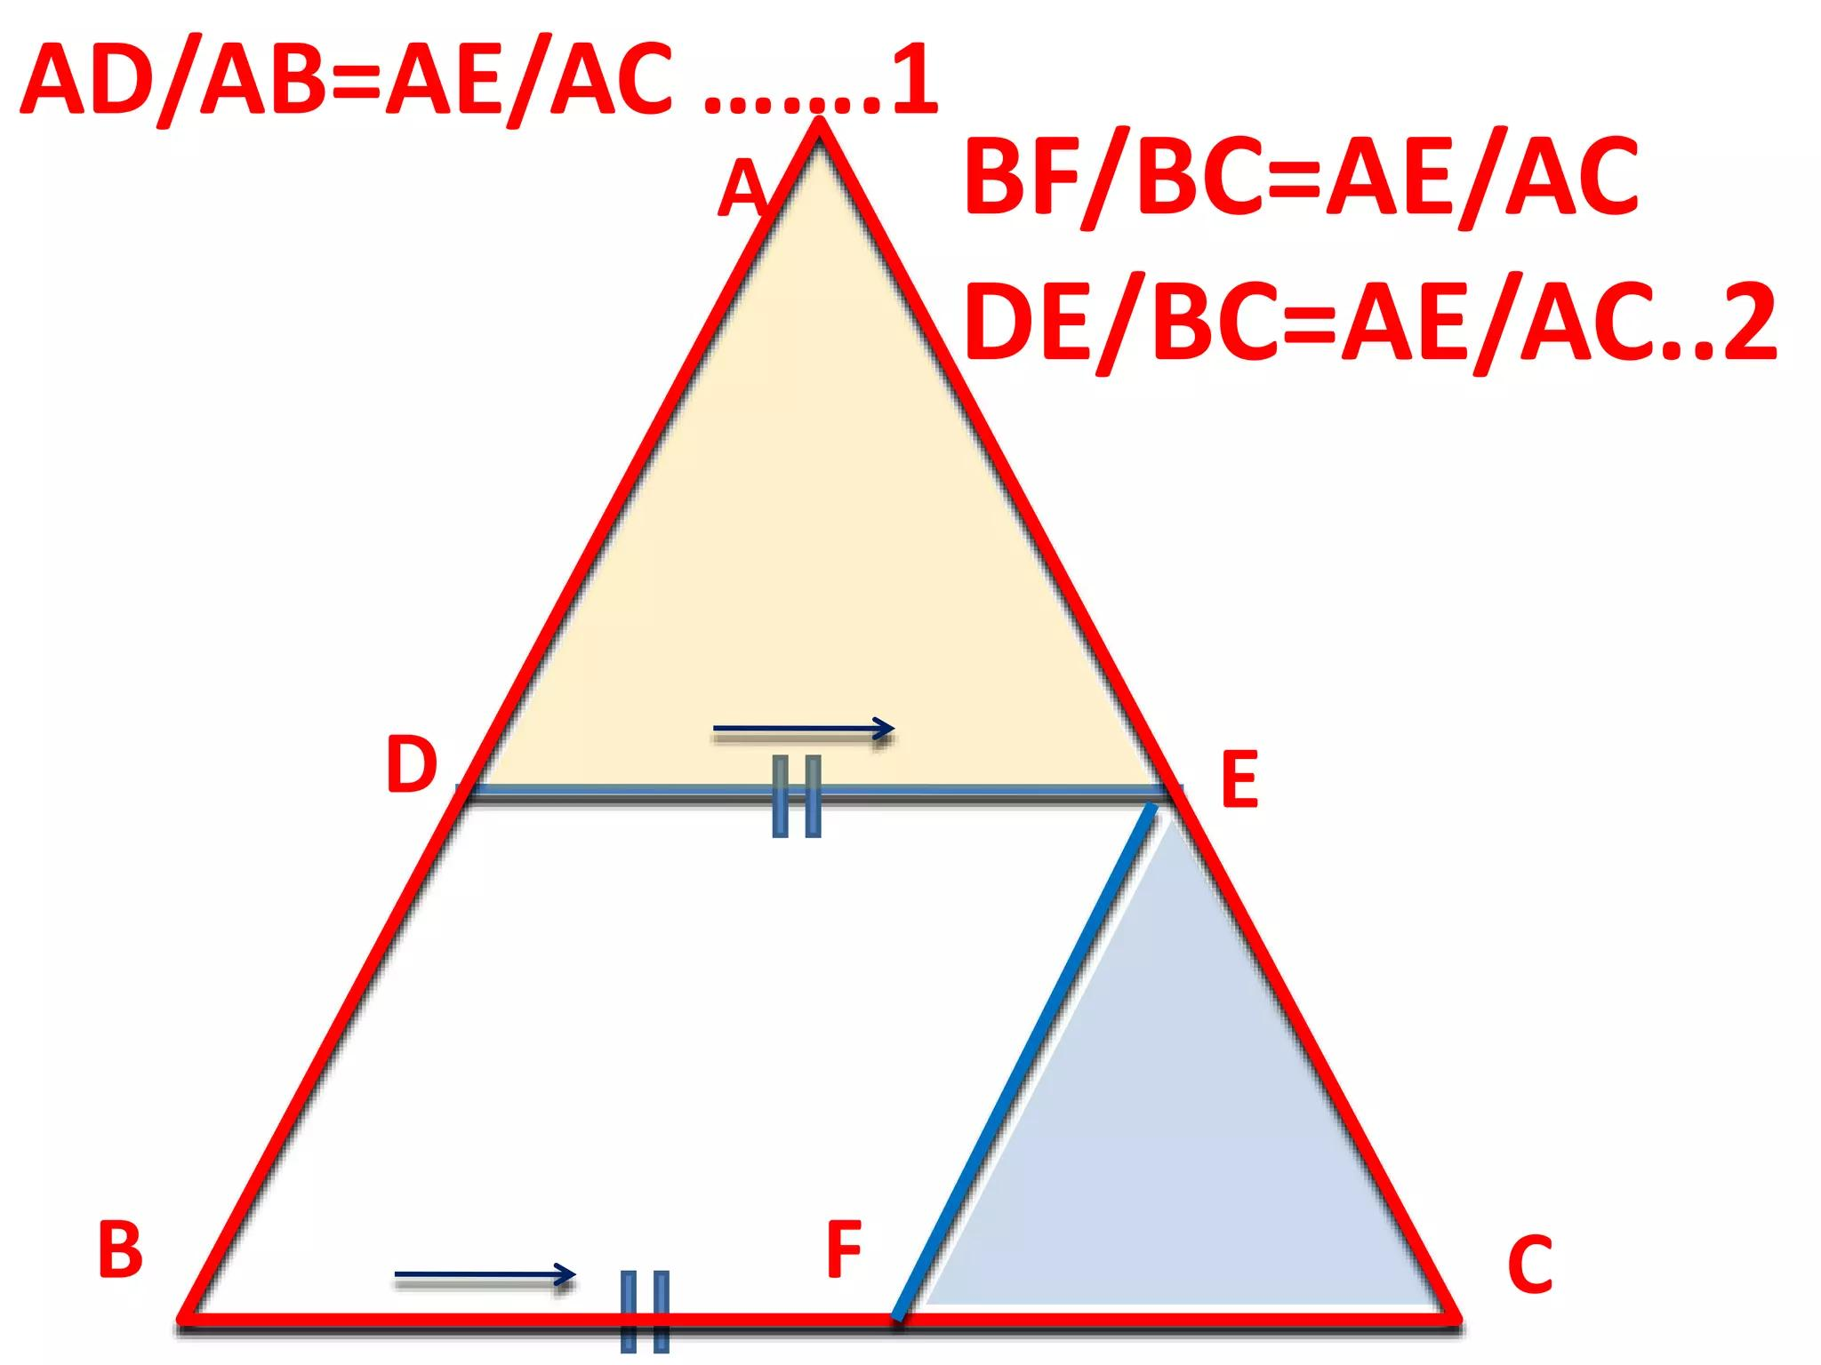
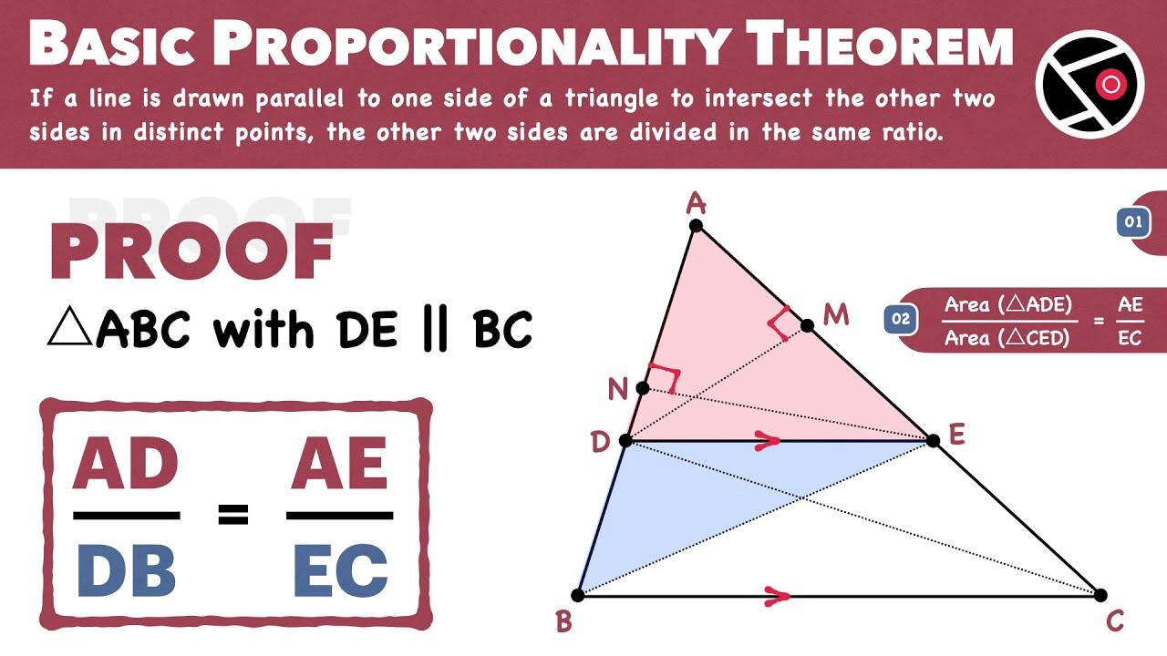
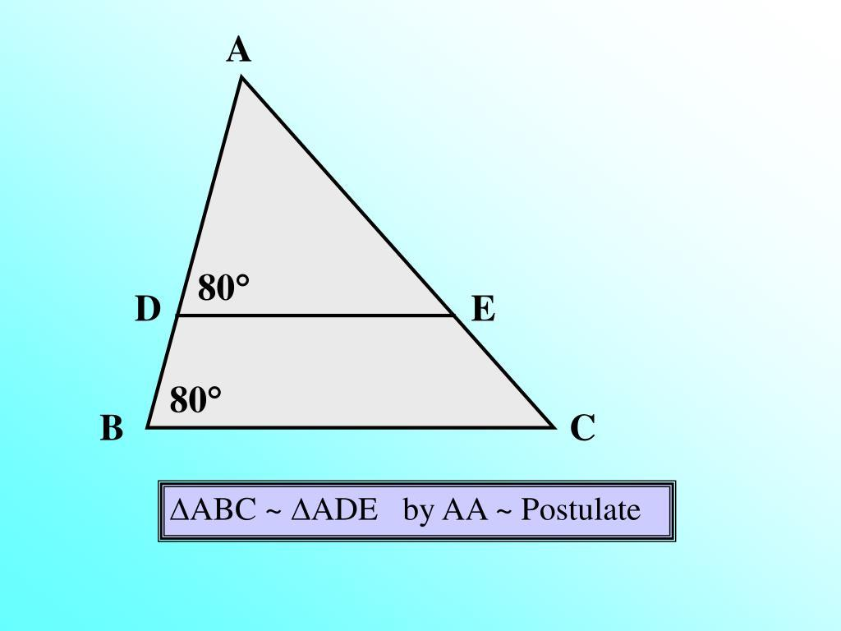
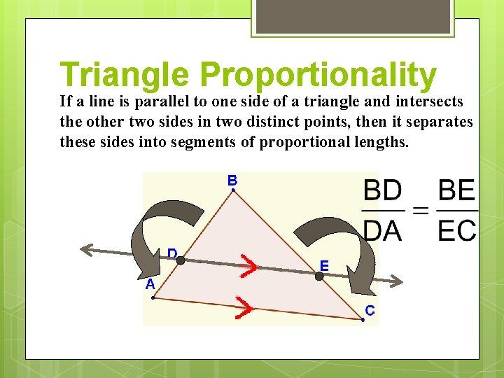

Converse of the Triangle Proportionality Theorem
# Source: AI Source: Provided by: [Data Path: Persons Table -> ID Column: 1, Name_En Column: Motasem Essam] -> From: [ChatGPT] on [7/25/2026]
The theorem also has a converse.
If a line divides two sides of a triangle proportionally, then the line is parallel to the third side.
If:
$$\boxed{\frac{AD}{DB}=\frac{AE}{EC}}$$
then:
$$\boxed{DE∥BC}$$
This is called the Converse of the Triangle Proportionality Theorem.

Example of the Converse
# Source: AI Source: Provided by: [Data Path: Persons Table -> ID Column: 1, Name_En Column: Motasem Essam] -> From: [ChatGPT] on [7/25/2026]
Suppose:
$$AD=4, DB=6$$
and:
$$AE=6, EC=9$$
Check:
$$\frac{AD}{DB}=\frac{4}{6}=\frac{2}{3}$$
and:
$$\frac{AE}{EC}=\frac{6}{9}=\frac{2}{3}$$
Since:
$$\frac{AD}{DB}=\frac{AE}{EC}$$
we conclude:
$$\boxed{DE∥BC}$$

Three-Segment Proportionality
# Source: AI Source: Provided by: [Data Path: Persons Table -> ID Column: 1, Name_En Column: Motasem Essam] -> From: [ChatGPT] on [7/25/2026]
The theorem can also be expressed using the entire sides:
$$\boxed{\frac{AD}{AB}=\frac{AE}{AC}}$$
and:
$$\boxed{\frac{DE}{BC}=\frac{AD}{AB}}$$
Therefore:
$$\boxed{\frac{AD}{AB}=\frac{AE}{AC}=\frac{DE}{BC}}$$
This shows that the smaller triangle is a scaled version of the larger triangle.

Scale Factor
# Source: AI Source: Provided by: [Data Path: Persons Table -> ID Column: 1, Name_En Column: Motasem Essam] -> From: [ChatGPT] on [7/25/2026]
Because:
$$△ADE∼△ABC$$
the scale factor from the large triangle to the small triangle is:
$$\boxed{k=\frac{AD}{AB}}$$
and also:
$$\boxed{k=\frac{AE}{AC}}$$
and:
$$\boxed{k=\frac{DE}{BC}}$$
For example, if:
$$AD=4, AB=12$$
then:
$$k=\frac{4}{12}=\frac{1}{3}$$
Therefore, every corresponding side of the smaller triangle is:
$$\boxed{\frac{1}{3}}$$
of the corresponding side of the larger triangle.

Conditions for the Theorem
# Source: AI Source: Provided by: [Data Path: Persons Table -> ID Column: 1, Name_En Column: Motasem Essam] -> From: [ChatGPT] on [7/25/2026]
The Triangle Proportionality Theorem requires:
- A triangle.
- A line segment connecting two sides of the triangle.
- The segment must be parallel to the third side.
For example:
$$DE∥BC$$
Without the parallel condition, the proportional relationship does not generally follow.

Triangle Proportionality vs Triangle Similarity
# Source: AI Source: Provided by: [Data Path: Persons Table -> ID Column: 1, Name_En Column: Motasem Essam] -> From: [ChatGPT] on [7/25/2026]
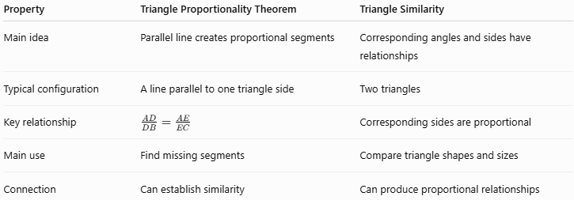
Property | Triangle Proportionality Theorem | Triangle Similarity
Main idea | Parallel line creates proportional segments | Corresponding angles and sides have relationships
Typical configuration | A line parallel to one triangle side | Two triangles
Key relationship | $$\frac{AD}{DB}=\frac{AE}{EC}$$ | Corresponding sides are proportional
Main use | Find missing segments | Compare triangle shapes and sizes
Connection | Can establish similarity | Can produce proportional relationships

Real-World Applications
# Source: AI Source: Provided by: [Data Path: Persons Table -> ID Column: 1, Name_En Column: Motasem Essam] -> From: [ChatGPT] on [7/25/2026]
Triangle proportionality is useful in:
- Architecture.
- Construction.
- Engineering.
- Surveying.
- Mapping.
- Scale drawings.
- Photography.
- Computer graphics.
- CAD.
- Model building.
For example, proportional triangles can be used to determine the height of an object from measurements taken at a smaller, accessible triangle.
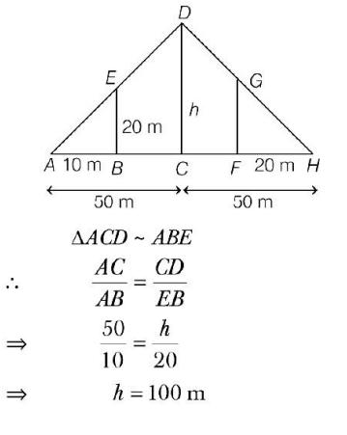
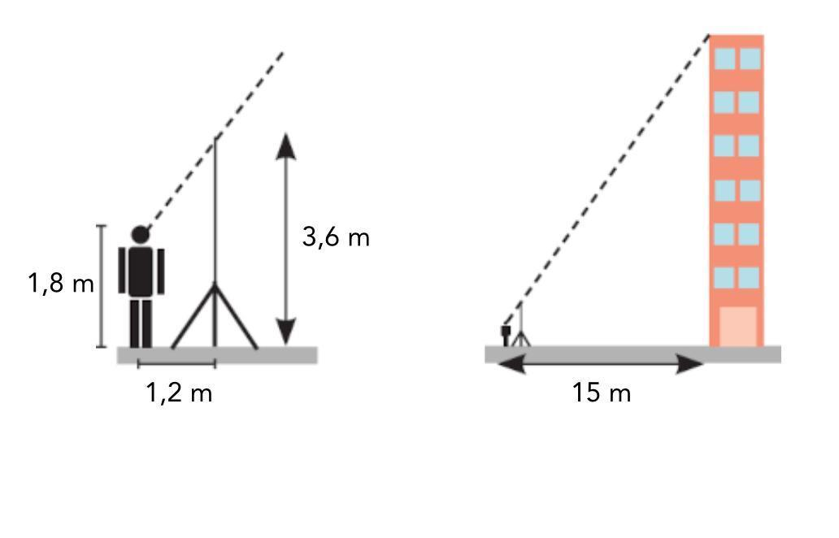
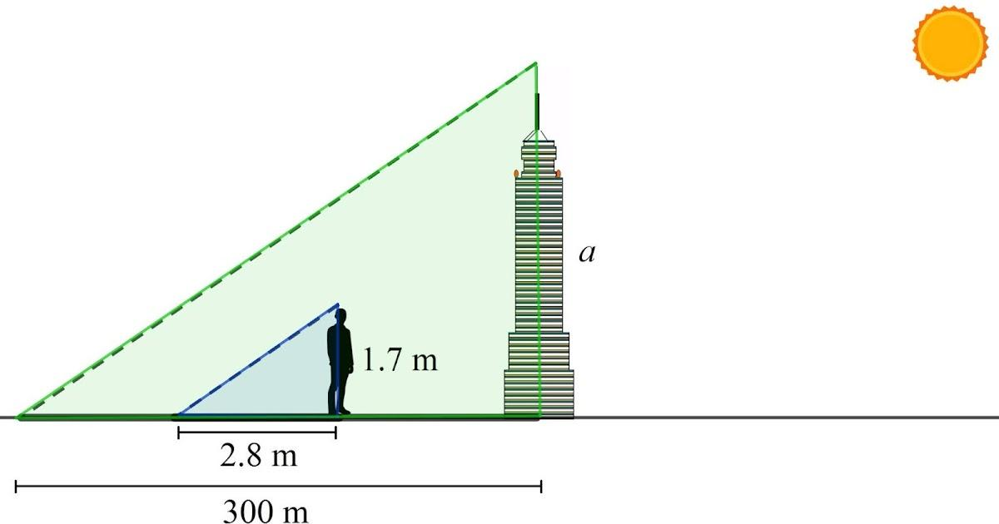
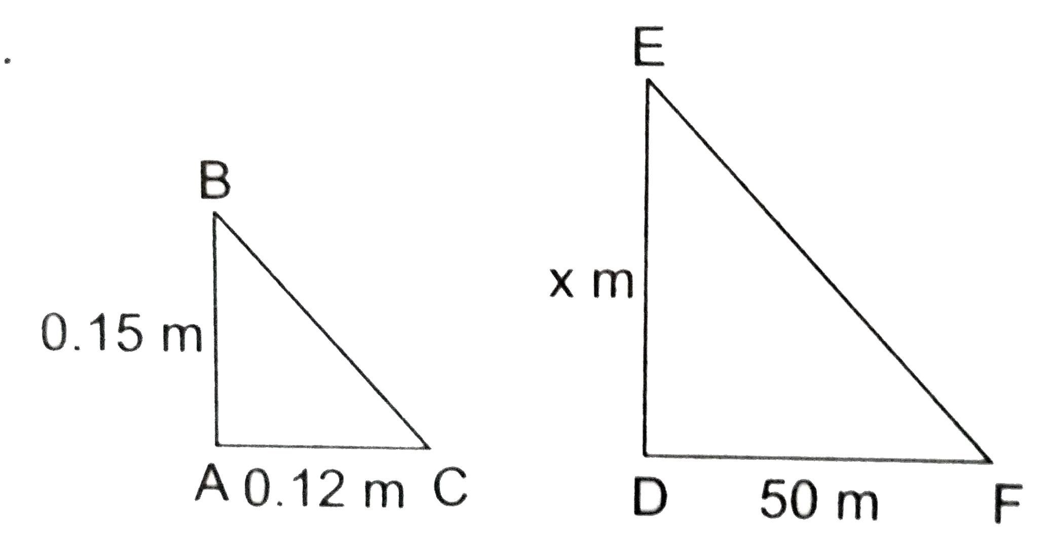
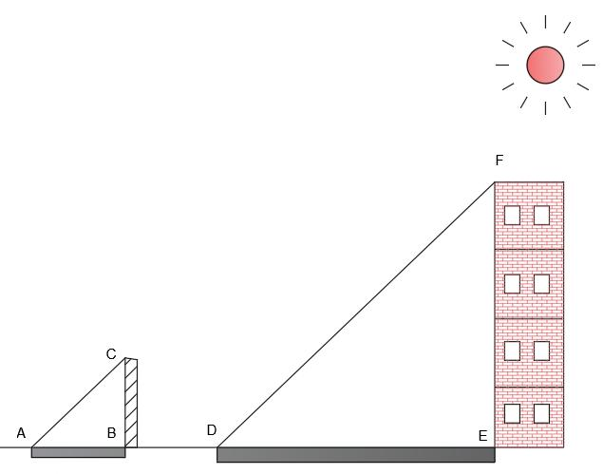

Applications
# Source: AI Source: Provided by: [Data Path: Persons Table -> ID Column: 1, Name_En Column: Motasem Essam] -> From: [ChatGPT] on [7/25/2026]
The theorem is important in:
- Plane Geometry
- Triangle Geometry
- Similarity
- Proportionality
- Trigonometry
- Coordinate Geometry
- Surveying
- Architecture
- Engineering
- CAD
- Computer Graphics

Advantages
# Source: AI Source: Provided by: [Data Path: Persons Table -> ID Column: 1, Name_En Column: Motasem Essam] -> From: [ChatGPT] on [7/25/2026]
The Triangle Proportionality Theorem helps to:
- Find unknown lengths efficiently.
- Establish proportional relationships.
- Prove lines are parallel.
- Establish relationships between similar triangles.
- Simplify geometric calculations.
- Solve practical measurement problems.

Limitations
# Source: AI Source: Provided by: [Data Path: Persons Table -> ID Column: 1, Name_En Column: Motasem Essam] -> From: [ChatGPT] on [7/25/2026]
The theorem:
- Requires a valid triangular configuration.
- Requires the relevant line to be parallel to the third side.
- Deals primarily with proportional lengths.
- Does not by itself determine all triangle measurements.
- Must be applied using corresponding segments correctly.

Comparison with Related Concepts
# Source: AI Source: Provided by: [Data Path: Persons Table -> ID Column: 1, Name_En Column: Motasem Essam] -> From: [ChatGPT] on [7/25/2026]
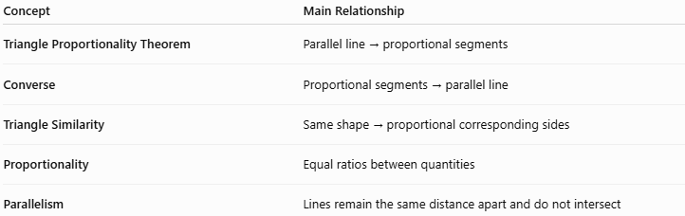
Concept | Main Relationship
Triangle Proportionality Theorem | Parallel line → proportional segments
Converse | Proportional segments → parallel line
Triangle Similarity | Same shape → proportional corresponding sides
Proportionality | Equal ratios between quantities
Parallelism | Lines remain the same distance apart and do not intersect

Key Points
# Source: AI Source: Provided by: [Data Path: Persons Table -> ID Column: 1, Name_En Column: Motasem Essam] -> From: [ChatGPT] on [7/25/2026]
- The Triangle Proportionality Theorem is also called the Basic Proportionality Theorem.
- A line parallel to one side of a triangle divides the other two sides proportionally.
- If:
$$DE∥BC$$
then:
$$\boxed{\frac{AD}{DB}=\frac{AE}{EC}}$$
- The corresponding whole-side relationship is:
$$\boxed{\frac{AD}{AB}=\frac{AE}{AC}}$$
- The smaller and larger triangles are similar:
$$\boxed{△ADE∼△ABC}$$
- The converse states that proportional division implies parallelism:
$$\boxed{\frac{AD}{DB}=\frac{AE}{EC}⇒DE∥BC}$$
- The theorem is widely used to find unknown lengths and establish geometric relationships.

Conclusion
# Source: AI Source: Provided by: [Data Path: Persons Table -> ID Column: 1, Name_En Column: Motasem Essam] -> From: [ChatGPT] on [7/25/2026]
The Triangle Proportionality Theorem states that a line drawn parallel to one side of a triangle divides the other two sides into proportional segments. For triangle $ABC$, if $DE∥BC$, then:
$$\boxed{\frac{AD}{DB}=\frac{AE}{EC}}$$
The theorem is directly connected to similar triangles, because the parallel line creates two triangles with the same shape but different sizes. Its converse can be used to prove that a line is parallel to a side of a triangle when proportional relationships are known. It is an important concept in plane geometry, similarity, proportionality, surveying, architecture, engineering, CAD, and measurement.

